Leanna Renee Hieber
Award-winning, Bestselling author for Kensington Books, Tor Books and Scrib’d
Actress, Playwright, Public Speaker, Ghost Tour Guide, Artist
Website: http://leannareneehieber.com
Twitter: http://twitter.com/LeannaRenee
Insta: http://instagram.com/leannareneehieber
FB: http://facebook.com/lrhieber
Etsy: http://etsy.com/shop/torchandarrow
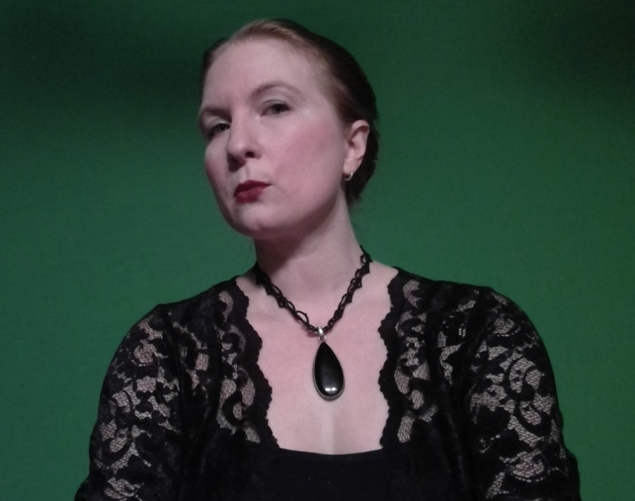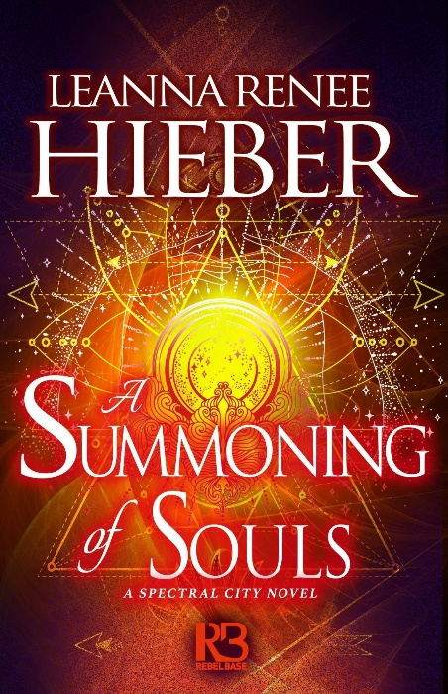
(340-word bio)
Leanna Renee Hieber is an actress, playwright and the award-winning, bestselling author of thirteen Gothic, Gaslamp Fantasy novels for adults and teens for Tor and Kensington Books such as the Strangely Beautiful saga, the Magic Most Foul trilogy, the Eterna Files trilogy and The Spectral City series. Her fiction career began with her futuristic paranormal novella Dark Nest, which won the 2009 Prism Award for best novella, given by the Futuristic, Fantasy and Paranormal chapter of RWA and the series continues with new installments and audiobooks via Scrib’d. Leanna’s Strangely Beautiful series hit Barnes & Noble and Borders Bestseller lists and garnered numerous regional genre awards, including three Prism Awards for best debut and fantasy novels, with revised editions now available from Tor. Darker Still hit the American Bookseller's Association "Indie Next List", was a Scholastic Book Club "Highly Recommended" title and was a finalist for the Daphne du Maurier award. The Spectral City, Leanna’s new ghost-filled series set in 1899 NYC with Kensington Books, has been a # 1 bestseller across several genres and digital platforms. A Haunted History of Invisible Women, Leanna’s first foray into nonfiction, with co-authors Andrea Janes and Elizabeth Kerri Mahon debuts 2022 from Kensington. Her short fiction has appeared in numerous notable anthologies and her books have been translated into many languages. She has been a guest of honor, panelist, performer and lecturer at countless conventions and writers’ organizations around the country and lectures at prominent institutions such as New York University. Leanna channels 19th century designer and visionary Clara Wolcott Driscoll in her performative lecture, By the Light of Tiffany. She is represented by Paul Stevens of the Donald Maass agency. A proud member of performer unions Actors Equity and SAG-AFTRA, she lives in New York City where she is a licensed ghost tour guide for Boroughs of the Dead and has been featured in film and television on shows like Boardwalk Empire and Mysteries at the Museum. For more information, as well as free reads, writers’ tips, resources and links to her art, visit http://leannareneehieber.com
--
(200-word bio)
Leanna Renee Hieber is an actress, playwright and the author of thirteen Gothic, Gaslamp Fantasy novels for adults and teens for Tor and Kensington Books such as the Strangely Beautiful saga, the Magic Most Foul trilogy, the Eterna Files trilogy and The Spectral City series. The Strangely Beautiful series hit Barnes & Noble and Borders Bestseller lists and garnered numerous regional genre awards, with revised editions of the complete series now available from Tor. The Spectral City has been a bestseller across several genres and digital platforms. A four-time Prism Award winner and Daphne du Maurier Award finalist, her short fiction has appeared in numerous anthologies and her books have been translated into many languages. She tours the country with By the Light of Tiffany: A Meeting with Clara Driscoll, a one-woman theatrical presentation about the 19th century designer of Louis Comfort Tiffany’s stained-glass lamps. A proud member of performer unions Actors Equity and SAG-AFTRA, she lives in New York City where she is a licensed ghost tour guide for Boroughs of the Dead and has been featured in film and television on shows like Boardwalk Empire and Mysteries at the Museum. http://leannareneehieber.com
--
For in-house use only, not public distribution: Leanna’s email: leanna@leannareneehieber.com
Please Note: Leanna only handles convention, appearance and email communication, scheduling and logistics via email as she’s not always on social media. Please don’t message her on Facebook especially, as she likely won’t see it! Thanks!
Latest novel release: A SUMMONING OF SOULS (Kensington Books, July 2020)
Latest short story release: A WINTER’S TALE (Pavane Press, Dec 2020) Featuring Leanna’s “Not So Lovely as Full of Glee”, a sequel to Edgar Allan Poe’s “The Oval Portrait”
Next release: 1 TBA novella (Spring 2021) and A HAUNTED HISTORY OF INVISIBLE WOMEN, 2022, Kensington
Ongoing releases: Leanna is a part of the Scrib’d and Bryant Street Publishing new original fiction program and is releasing new novellas in her DARK NEST CHRONICLES world, starting with “Time Immemorial: A Dark Nest Companion” as well as narrating the audiobook editions, through 2022

